PROJECT “Water wells in Sierra Leone”

I CONTEXT
- The action will be implemented in Sierra Leone.

Sierra Leone is a country located in West Africa. It is bordered by Guinea in the northeast, Liberia in the southeast, and the Atlantic Ocean in the southwest. Sierra Leone covers a total area of 71,740 km2 (27,699 sq mi) and has a population estimated at 6.4 million. Agriculture is by far the most important economic activity, but it is not sufficient for people sustainment. Since Independence (1961) Sierra Leone has never managed to find a socio-political balance and since 1992 has fallen in one of Africa's most brutal civil wars that ended ten years later in 2002. Before that conflict Sierra Leone was already one of the poorest countries on earth.

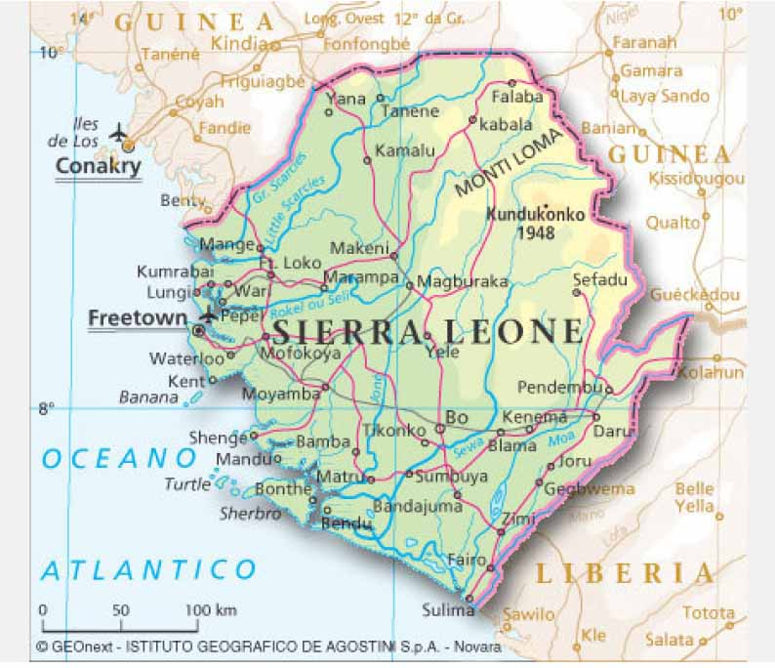
According to the indicators provided by international organizations, Sierra Leone ranks 176 out of 177 countries listed in 2006 UN Human Development Report. The average life expectancy is only 34 years, maternal mortality rates are the highest in the world. The per capita income does not exceed $ 150 per year, while 64% of the population remains illiterate. Despite progress in recent years, the country confirmed its first place for infant rates estimated at 170 per 1,000 live births, under-five mortality at 286 per 1,000 live births (nearly 1 of 3).
The situation shown by Key development indicators is the result of a long period of social and economic decline, and of the consequence of the civil war which lasted for about ten years and whose impact on living conditions and health of the population was devastating. The conflict has seriously eroded the capacity of families to meet their basic needs such as adequate food, access to drinking water, basic social and sanitation services. Despite humanitarian conditions remain critical, in the 7 years following the end of the conflict the country has been achieved a number of significant progress, whose success in the long run, will depends substantially on the resurgence of national economy.
The project will be implemented in the area of Lunsar a small town in the district of Port Loko, which is located about 120 km from the capital Freetown. The city has a strategic position, from a social and sanitation point of view ( there are a government health center, an hospital, an eye clinic and several schools). Lunsar is also an important commercial gateway for the territories of Marampa, Masimera, Buya Romende because of oil rice production, palm oil and almonds, and the processing of cassava and peanuts. The action is highly desired by the population and local authorities. All the water wells will be located in strategic areas in order to supply drinking water for the most needed families taking into accout their health conditions.

II BENEFICIARIES
Direct beneficiaries of the action are:
- former students trained in the local Vocational Training Center run by the missionaries of the Congregation of St. Joseph. They will have the opportunity to enter the world of labour drawing on the expertise gained in the construction of water wells during their school apprentiship;
- the people living in the villages involved in the initiative, which urgently need to stabilize and improve their food security, drinking potable water and increasing their agricultural productivity.

III OBJECTIVES
The project objective is to improve the living conditions of local communities in Sierra Leone through activities able to:
- Increase the skills among the beneficiaries with respect to the use of natural resources;
- combating desertification process;
- increase the production capacities among the beneficiaries in order to meet the basic needs of the population;
- reduce the possible negative effects, often fatal among children, of the use of non-potable water;

IV SUSTAINABILITY
- Socio-cultural
In general, the sustainability of the project is ensured by the strategy adopted, which is based on a participatory approach involving the local population and local institutions. Will be particularly valued the positive aspects of traditional socio-cultural conditions, which may represent a resource and a hope of rebirth and development.
- Environmental impacts
All actions under this initiative take into account ecological factors and also favour the recovery of depleted soils by irrigation initiatives. This process should provide a reproducible model and have a strong impact on the population of rural villages that will be suitably informed and sensitized on environmental health issues.

V IMPLEMENTATION OF THE ACTION
- Methodologies adopted and planned activities
The action is proposed to build a water well in a village, and will be implemented through very simple activities:
1^ PHASE The first phase of the initiative is the establishment of a team of students to be entrusted with the task of the digging of the well and the other works planned. Then a management committee will be set up in the in order to ensure the maximum participation of the beneficiary population.
2^ PHASE The second phase is the digging of the water well. We will proceed to:
a) carry out the excavation of the well in the target village;
b) Place the cement rings in order to make the well more strong and avoid wall collapses
c) Place the hand pump on the lid of cement that close the well.
d) The excavation will be done with traditional techniques and at very low costs. The tools will be simple and appropriate to the local knowledge so that, once completed, the wells will be safely operated and maintained by the locals.
CHRONOGRAM
The duration of the action is about 12 months since the effective realization of a well in Sierra Leone is tied to the rainy season, Sierra Leone.
Activities | Months
Activities | 1 | 2 | 3 | 4 | 5 | 6 | 7 | 8 | 9 | 10 | 11 | 12
1^ PHASE
Establishment of a team of students and set up of a management committee in the village.
2^ PHASE
Excavation of the well, placement of the cement rings, placement of the pump and final settings.

VI FINAL PHASE
To complete the work, after the full implementation of the well water project, a plaque will be affixed to thanks with the words "DONATED BY CIELO E TERRA SPA – ITALY – 1/2010"

Implementing Agency | ENGIM internazionale ong
Date of establishement | 6th of december 1977
Legal Status | Non for profit italian NGO accredited upon the Italian Ministry of Foreign Affairs (italian Law nr. 49/87)
Address in Rome | Via Belvedere Montello, 77 – 00166 Roma
N° di telefono: | +39/06/62.43.400
N° di fax: | +39/06/233.225.987
E-mail: | f.farnesi@engiminternazionale.org
Codice Fiscale: | 80354630586
Address in Vicenza
Indirizzo: | Contrà Vittorio Veneto, 1- 36100 Vicenza
N° di telefono: | +39/444/32.29.03
N° di fax: | +39/444/32.23.61
E-mail: | a.pellizzari@engiminternazionale.org
Total cost for one Water Well complete with pump | € 4.000 1 water well with hand pump  of which:  € 360 General expenses (9%)  € 140 equipment for workers in Sierra Leone (3%)  € 3.500 cost for completion of the well (88%)  € 4.000 Total (100%)
Country | Sierra Leone
Local Partners | “St. Joseph” vocational Institute - Lunsar (Sierra Leone) Congregation of Saint Joseph Fathers
Contact person for the action
In Sierra Leone: | P. Mario Zarantonello
In Italy: | Dott. Alessandro Pellizzari
Bank account
Account number (IBAN Code): | IT78E 05696 03217 00000 3166 X92
Name of the Bank: | Banca Popolare di Sondrio – agency Roma 17
Reason for payment : | Water wells in Sierra Leone
To the account of: | ENGIM ong

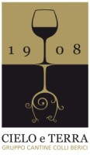 | 

Vicenza, 16th november 2009
Alessandro Pellizzari
E.N.Gi.M. internazionale o.n.g

